F2024332166 aiman khurshid
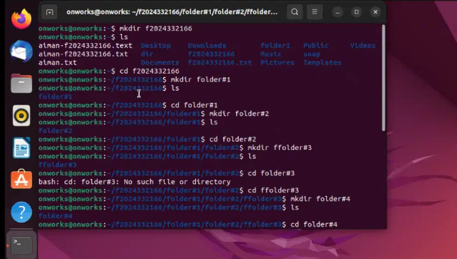
First I creat a folder with the name of my ID then list the folder.IN next step I open the folder and creat another folder 1 within id folder and 2 folder in 1 folder and so on upto 5 .

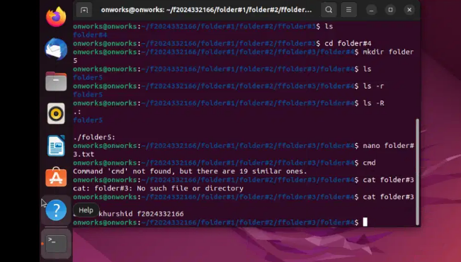
In 3rd step I run the recuraction command ,then creat the file with name of folder#3 and write some information and press ctrl s to save file and ctrl x to exit .now use cat command to display information of folder#3 on console.

